COMPUTER NETWORKS LAB MODEL PRACTICAL
NAME : TONY WINSTON T
REG NO.: 1924260006
SLOT : A

EXPERIMENT : 1 (OUTPUT AND SCREENSHOT)
OUTPUT:
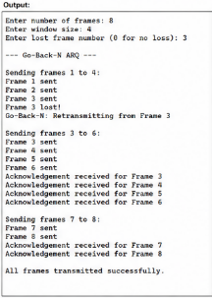

SCREENSHOT:
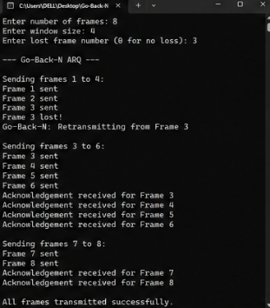

EXPERIMENT : 2

OUTPUT:
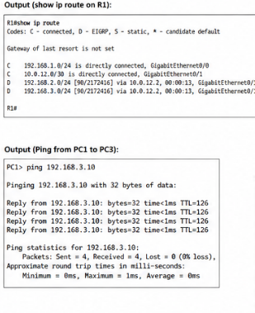
SCREENSHOT:
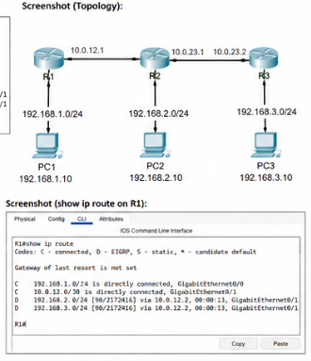

EXPERIMENT : 3

OUTPUT AND SCREENSHOT:

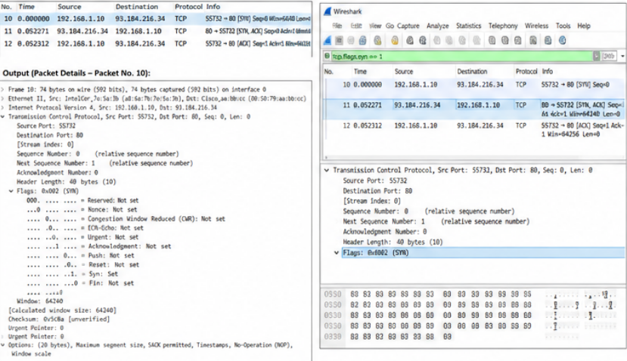

EXPERIMENT 4:

OUTPUT AND SCREENSHOT:

